Project-2.R

Duc

2019-11-06

#1)   
p = c() #Creating empty vectors  
diff = c()  
sum = c()  
for (n in 0:200) {  
 k = ((-1)^n)*(1/(2*n+1)) #Leibniz's series formula  
 p = append(p, k, after= length(p)) #Append value of k into the empty vector p  
 s = sum(p) #Sum up all values of p calculated up to x in [0,200]  
 d = (pi/4) - s #Difference between actual pi/4 and the approximation up to x in [0,200]  
 diff = append(diff,d,after=length(diff))  
 sum = append(sum,s,after=length(sum)) #Appending the sum and difference   
}  
  
n = c(0:200)  
par(mfrow=c(1,2))  
plot(n,diff,type="l", xlab = "n", ylab="Pi/4 - Sum(n)")  
plot(n,sum,type = "l",xlab = "n", ylab="Sum(n)")

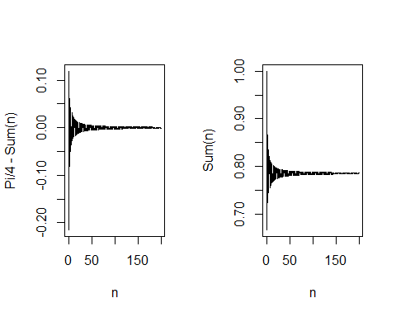

#2)  
z = seq(800,1500,1)  
pd = dnorm(z,1152,84)  
  
par(mfrow=c(1,3))  
plot(z,pd,type= "l")  
polygon(c(z[z>=1250],1250), c(pd[z >= 1250], 0), col = "red")  
  
plot(z,pd,type= "l")  
polygon(c(z[z<=1200],1200), c(pd[z <= 1200],0), col = "red")  
  
plot(z,pd,type= "l")  
polygon(c(1000,z[z>=1000 & z<= 1100],1100),c(0,pd[z>= 1000 & z<=1100],0),col = "red")

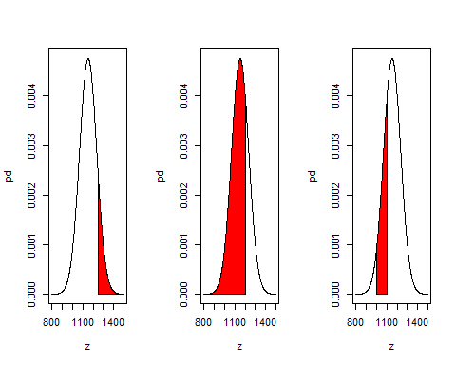

#3)   
temp = read.table("temperature.csv", sep = ",", header = T)  
temp = temp[,3:7]  
attach(temp)  
names(temp)

## [1] "temperature" "lower" "rain" "month" "yr"

m = factor(month) #Assigning the 'month' to be factor  
plot(m, temperature, xlab = "Month", ylab = "Daily Maximum Temperature")  
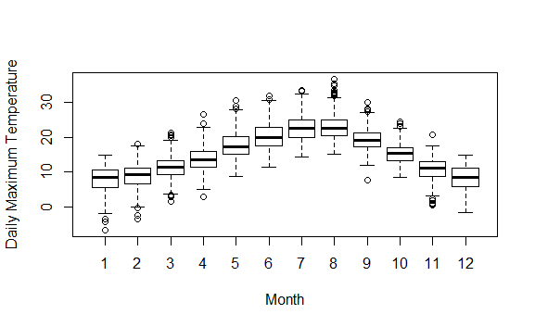

#4)  
prob = seq(0.1,0.9,0.1) #Probability vector from 0.1 to 0.9  
success = seq(0,8,1) #Number of possible successes in 8 trials  
p = c()  
for (j in prob){  
for (i in success) {  
 c = factorial(8)/(factorial(8-i)*factorial(i))  
 prob = c*(j)^i*(1-j)^(8-i)  
 p = append(p,prob,after=length(p))  
 }  
}  
#Dividing success according to the probability into 9 vectors.  
#Each vector holds the probability of x number of success given the prob of success  
suc0 = p[1:9]  
suc1 = p[10:18]  
suc2 = p[19:27]  
suc3 = p[28:36]  
suc4 = p[37:45]  
suc5 = p[46:54]  
suc6 = p[55:63]  
suc7 = p[64:72]  
suc8 = p[73:81]  
  
#Graphing the 9 plots of probability ranging from 0.1 to 0.9  
par(mfrow = c(3,3))

barplot(suc0,xlab = '# of successes',ylab = 'Probability',main = "p = 0.1")  
barplot(suc1,xlab = '# of successes',ylab = 'Probability',main = "p = 0.2")  
barplot(suc2,xlab = '# of successes',ylab = 'Probability',main = "p = 0.3")  
barplot(suc3,xlab = '# of successes',ylab = 'Probability',main = "p = 0.4")  
barplot(suc4,xlab = '# of successes',ylab = 'Probability',main = "p = 0.5")  
barplot(suc5,xlab = '# of successes',ylab = 'Probability',main = "p = 0.6")  
barplot(suc6,xlab = '# of successes',ylab = 'Probability',main = "p = 0.7")  
barplot(suc7,xlab = '# of successes',ylab = 'Probability',main = "p = 0.8")  
barplot(suc8,xlab = '# of successes',ylab = 'Probability',main = "p = 0.9")

